/home/marotant/dev/Expert_op4grid_recommender/data/bare_env_20240828T0100Z

/home/marotant/dev/Expert_op4grid_recommender/data/action_space/AllFrance_coupling_reco_deco_actions_20240828T0100Z.json

/home/marotant/dev/Expert_op4grid_recommender/data/bare_env_20241125T1400Z

/home/marotant/dev/Expert_op4grid_recommender/data/action_space/AllFrance_coupling_reco_deco_actions_20241125T1400Z.json

Prioritized actions are: ['reco_CHALOL31LOUHA', 'reco_GEN.PY762', 'node_merging_PYMONP3', 'f344b395-9908-43c2-bca0-75c5f298465e_COUCHP6', '3617076a-a7f5-4f8a-9009-127ac9b85cff_VIELMP6']
reco_CHALOL31LOUHA
Rho reduction from [1.01] to [0.78]
New max rho is 1.09 on line CHALOL31LOUHA
reco_GEN.PY762
Rho reduction from [1.01] to [0.98]
New max rho is 0.98 on line BEON L31CPVAN
Warning: Fast load flow failed or diverged (status: ComponentStatus.FAILED). Retrying in slow mode...
Warning: Load flow with PREVIOUS_VALUES failed (com.powsybl.commons.PowsyblException: Voltage magnitude is undefined for bus '.A.ZA 6_0'). Retrying with DC_VALUES...
node_merging_PYMONP3
Rho reduction from [1.01] to [0.8]
New max rho is 0.90 on line CLAVAL31GAVE5
f344b395-9908-43c2-bca0-75c5f298465e_COUCHP6
Ouverture COUCHP6_COUCH6COUPL DJ_OC dans le poste COUCHP6
Rho reduction from [1.01] to [0.95]
New max rho is 0.95 on line BEON L31CPVAN
3617076a-a7f5-4f8a-9009-127ac9b85cff_VIELMP6
Ouverture VIELMP6_VIELM6COUPL DJ_OC dans le poste VIELMP6
Rho reduction from [1.01] to [1.]
New max rho is 1.00 on line BEON L31CPVAN
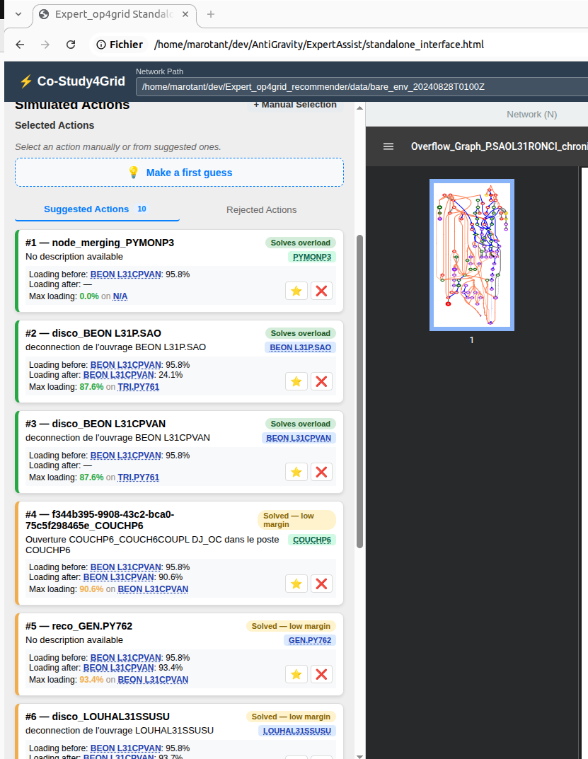
[Timer] Reassessment took 6.1451s

In slow mode

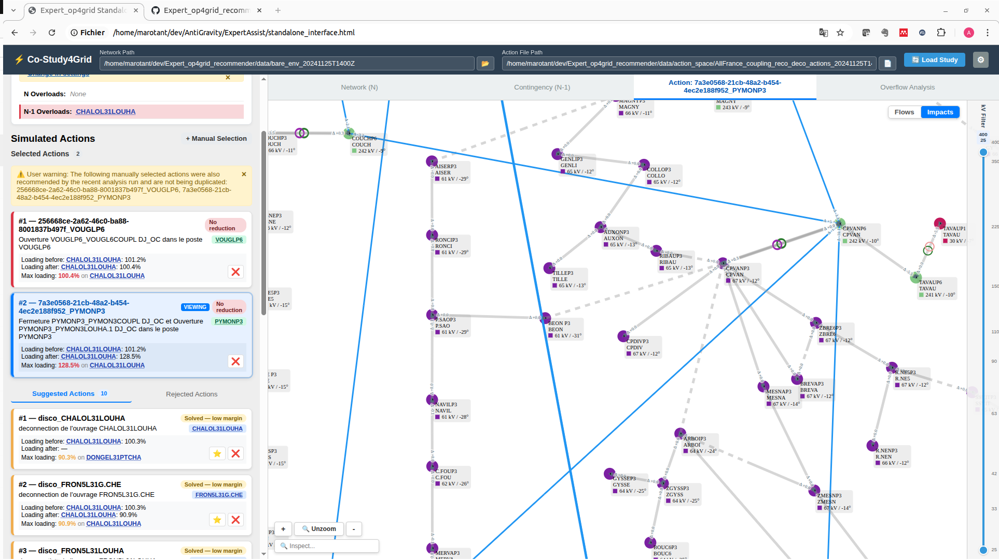

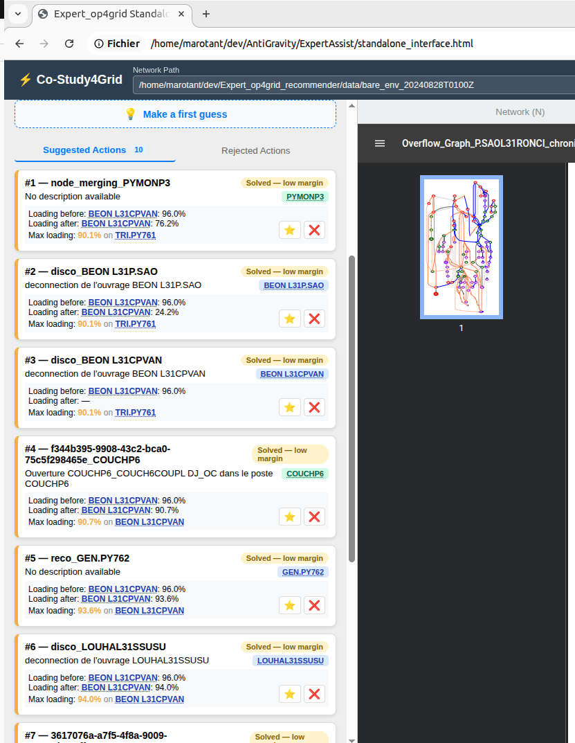
With Fast mode

